**AI LAB PROGRAMS**

**OUTPUT SCREENSHOTS**

1. Implementation of Tic-Tac-Toe game

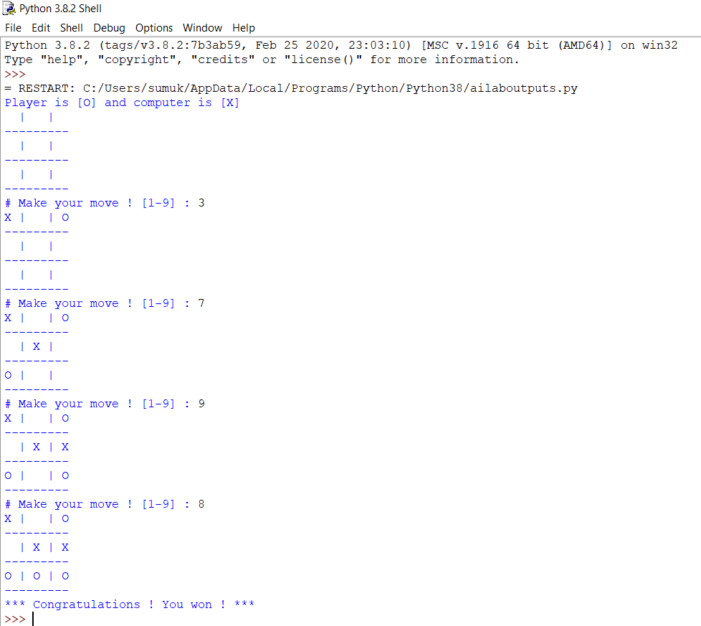

1. Solving 8 puzzle problem

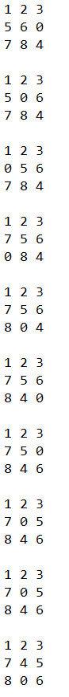 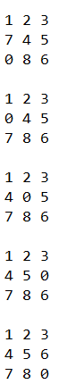

1. Implementation of vacuum cleaner agent

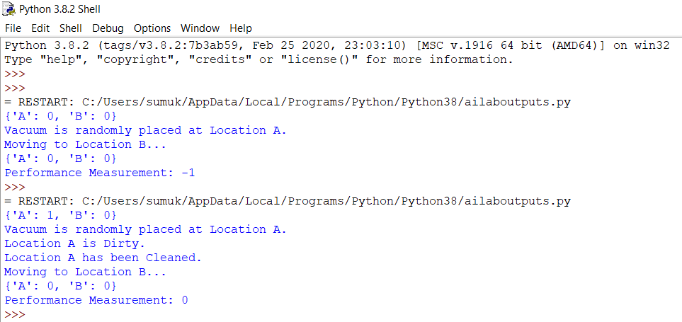

1. Implementation of A* search algorithm

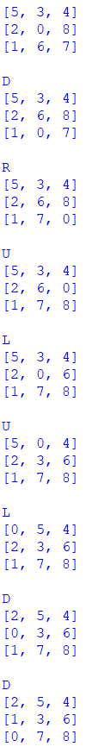 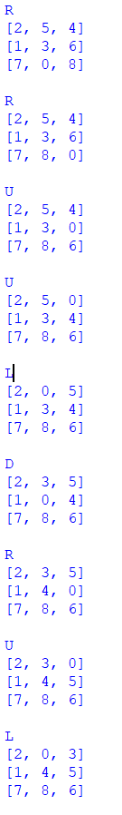 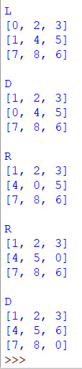

1. Implementing iterative deepening search to solve 8 puzzle problem

         

      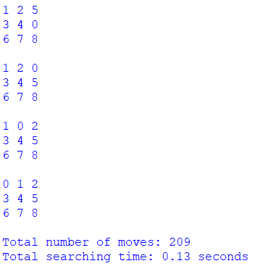

1. Create a knowledge base using prepositional logic and show that the given query entails the knowledge base or not

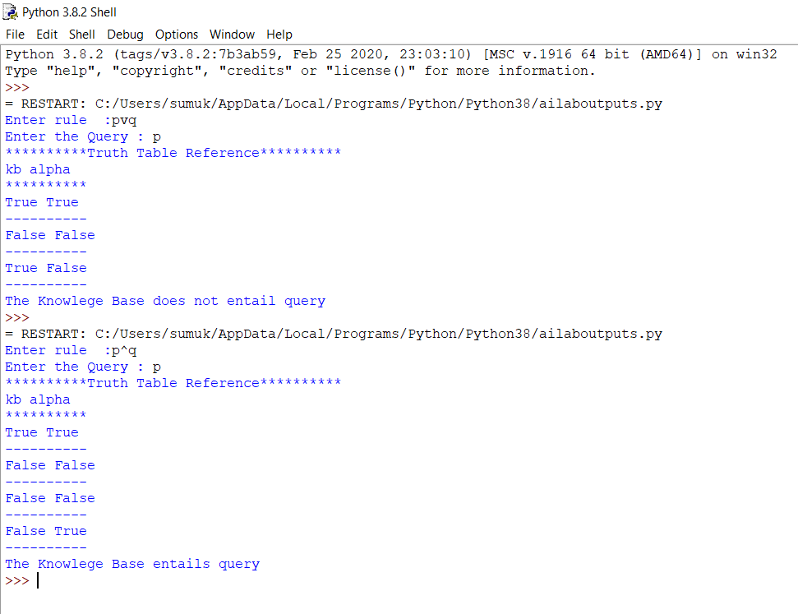

1. Convert the given first order logic statement into conjunctive normal form (CNF)

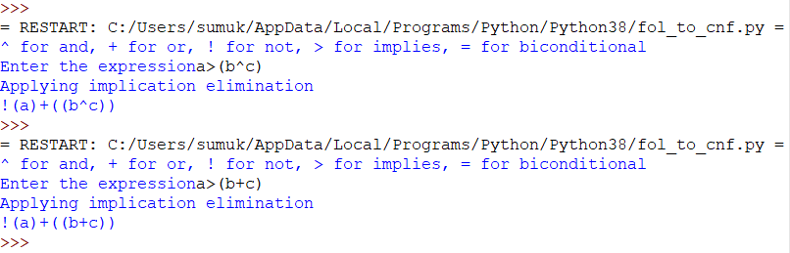

1. Implementation of unification in first order logic

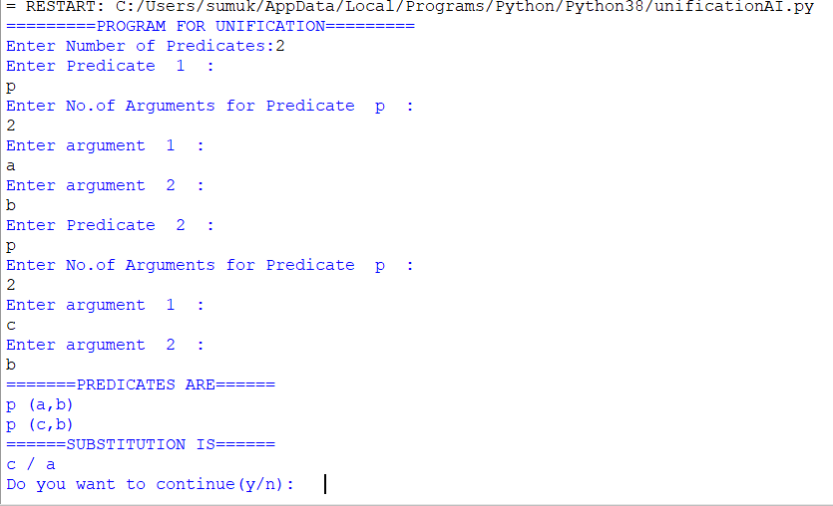

1. Create a knowledge base consisting of first order logic statements and prove the query using forward reasoning

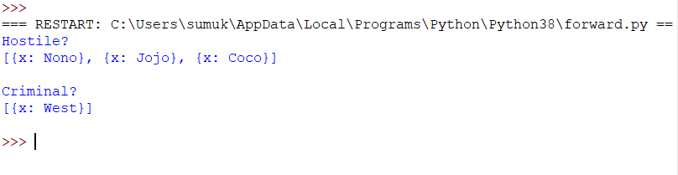

1. Demonstrate decision tree learning for a given set of training examples and test data

